Application Main Page



1. Main form/page opens.

2. Individual clicks to enter application.

Login Page

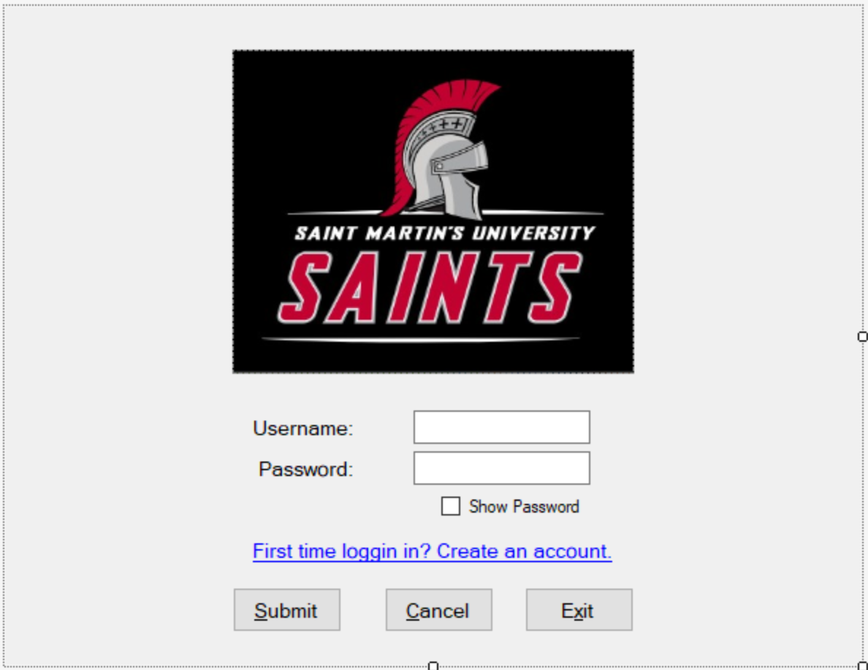

Upon login (or Enter):

Validate username:

Has something in it

Contains no SQL characters

Is in system

Validate password:

Is not empty or null

Contains no SQL characters

Matches password for username

3 x unsuccessful login attempts lock account for period of time

Register Page

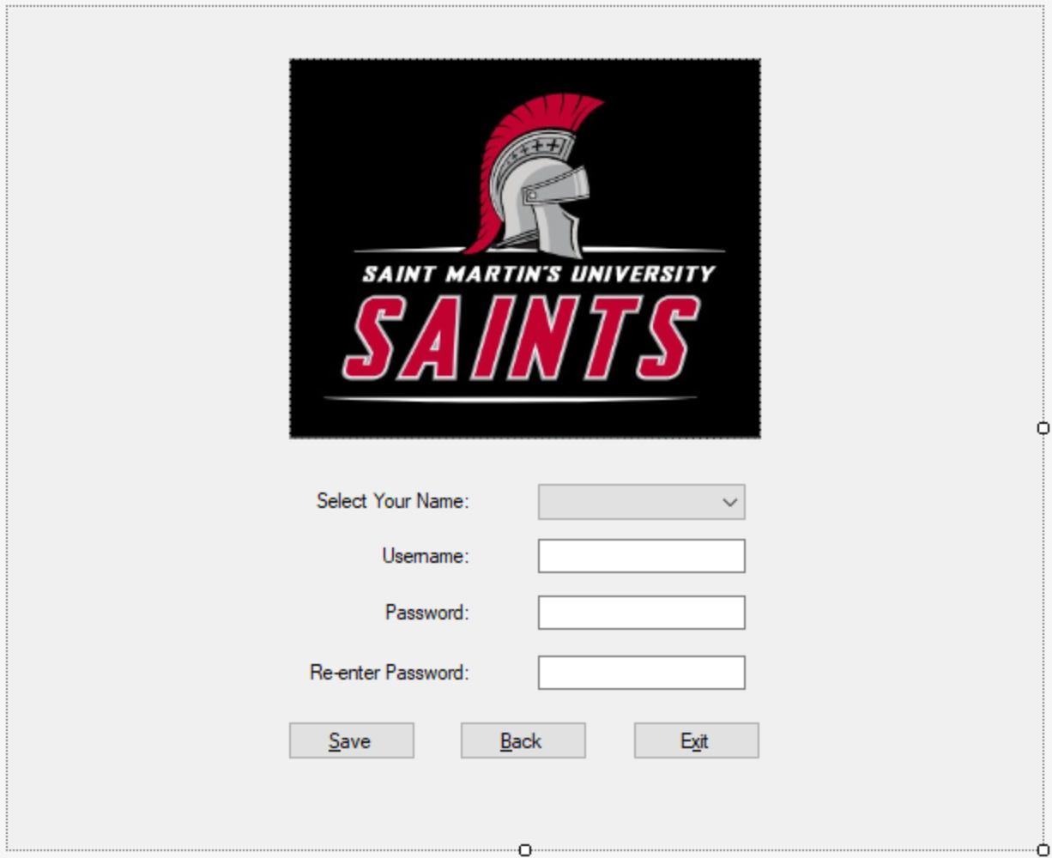

List box containing available names:

* Active
* Not already assigned username

Validate username :

* Contains no SQL characters
* Not already used

Validate password :

* Contains no SQL characters
* Is appropriate length
* Passwords match

User Main Page

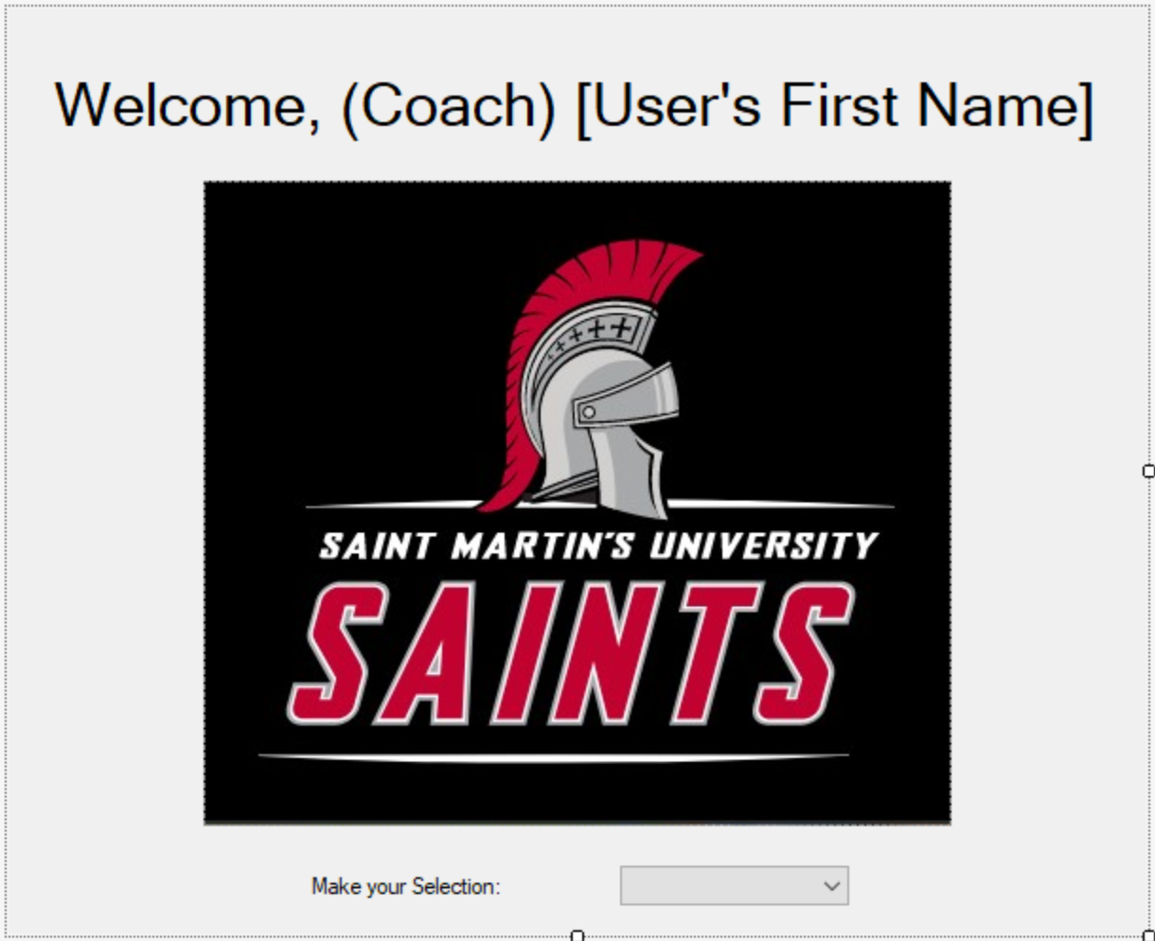

If user is coach, display “Coach” in front of first name.

List box options:

* Courses:
  + Add
  + Edit
* Round Details:
  + Add
  + Edit
* Reports:
  + Overall
  + By Date
  + By Course
  + By Tournament
  + Team Aggregate (Coaches only)
  + By Individual (Coaches only)
* User (Coaches only):
  + Add
  + Edit
* Logout

Add/Edit User Page

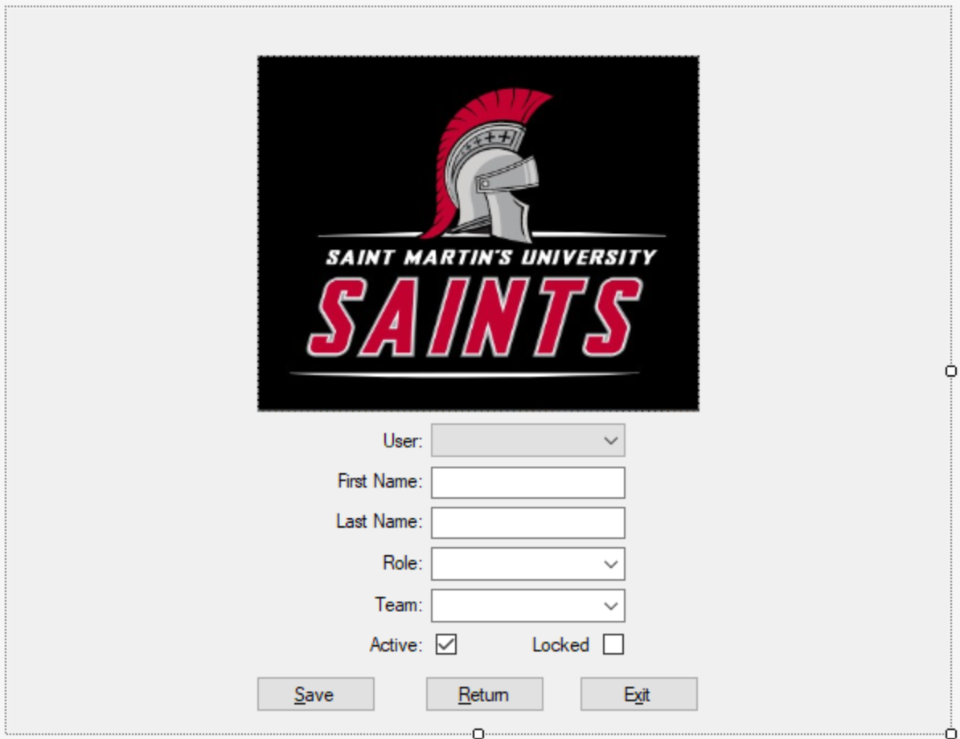



List box options:

* Add new user
* Users: (Associated team users – alphabetical)
* Return to previous menu
* Logout

Active checkbox: Default is checked. (Display only in editing mode.)

Validate input of name information:

* Is not empty or null
* Contains no SQL characters

Role options:

* Coach
* Player

Team options:

* Men
* Women

Locked checkbox: Default is unchecked. (Display only in editing mode.)

Add/Edit Course Page

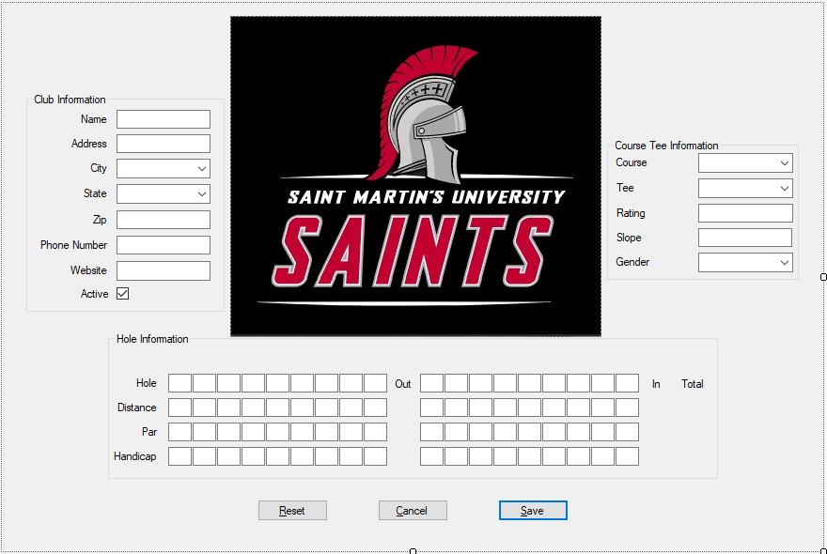



Address, City, State, Zip, Phone Number, and Website not required for current app.

Combo boxes:

* Club name:
  + If not listed, type in.
* Course name:
  + If not listed, type in.
* Tee name:
  + If not listed, type in.
* Gender (F or M)

Text boxes: (Accept integers only)

* Rating
* Slope
* Hole Numbers (Saved as string)
* Distance
* Par
* Handicap

Reset button clears all controls.

Cancel button returns to User Main page.

Save button validates input:

* Required fields not empty or null
* Numbers are numbers
* No SQL characters
* Sends data to database

Add/Edit Round

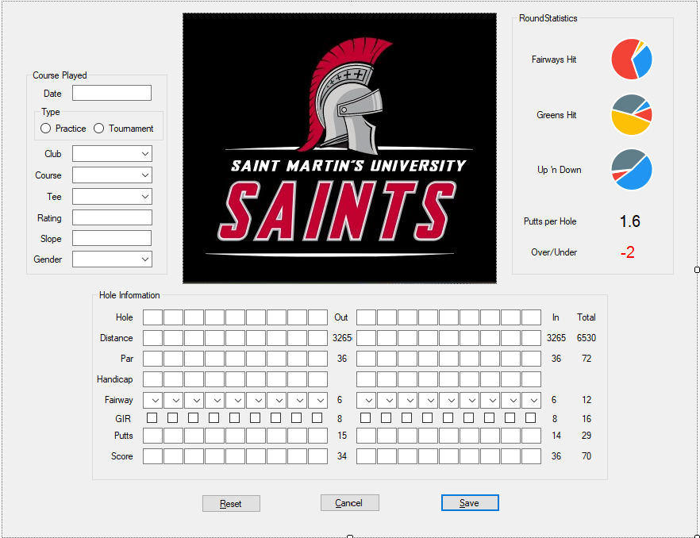



Date:

* Use date picker.
* Validate not later than today.

Type:

* Default Practice

List boxes:

* Club – display available clubs
* Course – display available courses at club
* Tee – display available tees at course
* Gender – automatically selected based on team and tee

Text boxes:

* Rating, Slope, Hole Numbers, Distances, Pars, Handicaps populated, Distance Out/In/Total, and Par Out/In/Total based on tee selection

Combo box:

* Fairway options – H(it), L(eft), and R(ight)

Text boxes:

* Putts and Score accept integers only
* Counts for Fairways Hit Out/In/Total, GIR Out/In/Total, Putts Out/In/Total, and Score Out/In/Total calculated as data is entered

Checkboxes:

* GIR automatically determined:
  + If Score - # Putts <= Par – 2, then check.

Statistics: (LiveCharts)

* Fairways Hit:
  + % of tee shots hit (count(H)/number of holes par != 3)
  + % of tee shots left (count(L)/number of holes par != 3)
  + % of tee shots right (count(R)/number of holes par != 3)
* Greens Hit:
  + % of GIR/number of holes
  + % of !GIR/number of holes
* Up ‘n Down: (Men only)
  + % of putts = 1
* Putts per Hole:
  + Total putts/number of holes
* Over/Under:
  + Total par – total strokes

Buttons:

* Reset – clears all controls
* Cancel – returns to User Main page
* Save:
  + Validates entry in Fairway Hit combo box
  + Putts/Score:
    - Is not empty or null
    - Is integer
  + Sends round data to database

Individual/Team Statistics Page

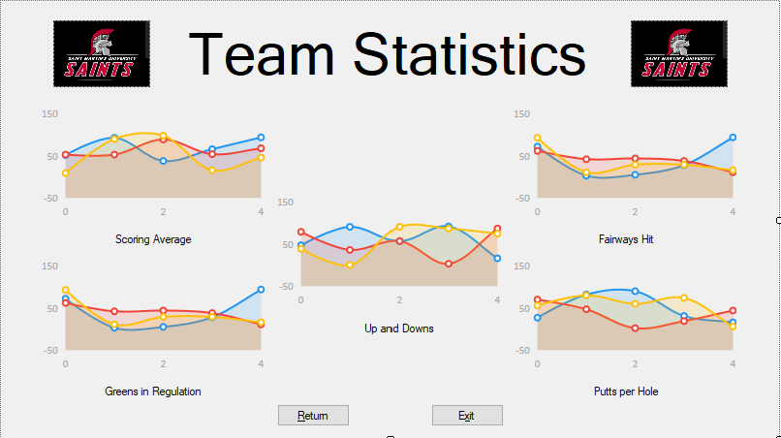

If user is coach and displaying team statistics, each colored line represents a single player on appropriate team.

If user is player or coach that chooses individual statistics, each graph is to display three lines:

* One color represents tournament performance
* Another color represents practice performance
* Third color represents overall average performance